Flood Detection and Water Monitoring System Using IOT

Abstract:

Since we are now currently present in an era of Computing Technology, it is essential for everyone and everything to be connected to the internet. IOT is a technology that brings us more and more close to this goal. Our project comprises of smart water monitoring system which is a small prototype for flood detection and avoidance system. This paper explains the working and the workflow of all the components present inside our project. The sensors sense the environment and sends real-time data to the cloud (firebase cloud) and users can view and access this data via their mobile platform. The model gives a warning after the water level rises to a particular height. Since it is a small scaled prototype for flood detection and avoidance system, the working of this model is good. The data are uploaded and changed in the cloud in precision to the sensor and real-time changes in the mobile application is achieved. This model can be used to greatly reduce the casualties in a

devastating event of flood.

Introduction:

We are witnessing various drastic advancements in the fields of science and technology over the past few decades. The current industrial age has revolutionized our lives and provides us with plenty of comforts and conveniences. However, this industrial progress has come at a hefty cost of global warming and other environmental disasters such as flood, earthquake, etc. Furthermore, the loss caused by such disasters to life and property is immense. The increasing carbon footprints and greenhouse gases have severely led to an imbalance and disturbances in the natural cycle of rains and floods. Hence, we are facing the dangers of unwarned and

inevitable floods more than ever before.

Implementation method

Figure1:

The main idea in our project is to integrate two platforms android and iot in order to realize a system that is dependable of easy to access at the same time. We use Arduino and different sensors in order to collect and upload the data to a real time database and android to use this data for monitoring purpose. Hardware implementation Different hardware used in our projects are:

i)Arduino Wemos D1 R1.

ii)Ultrasonic sensor.

iii)Flow sensor.

iv)Dht11(Temperature and humidity sensor)

v)Float sensor.

vi)LCD Display.

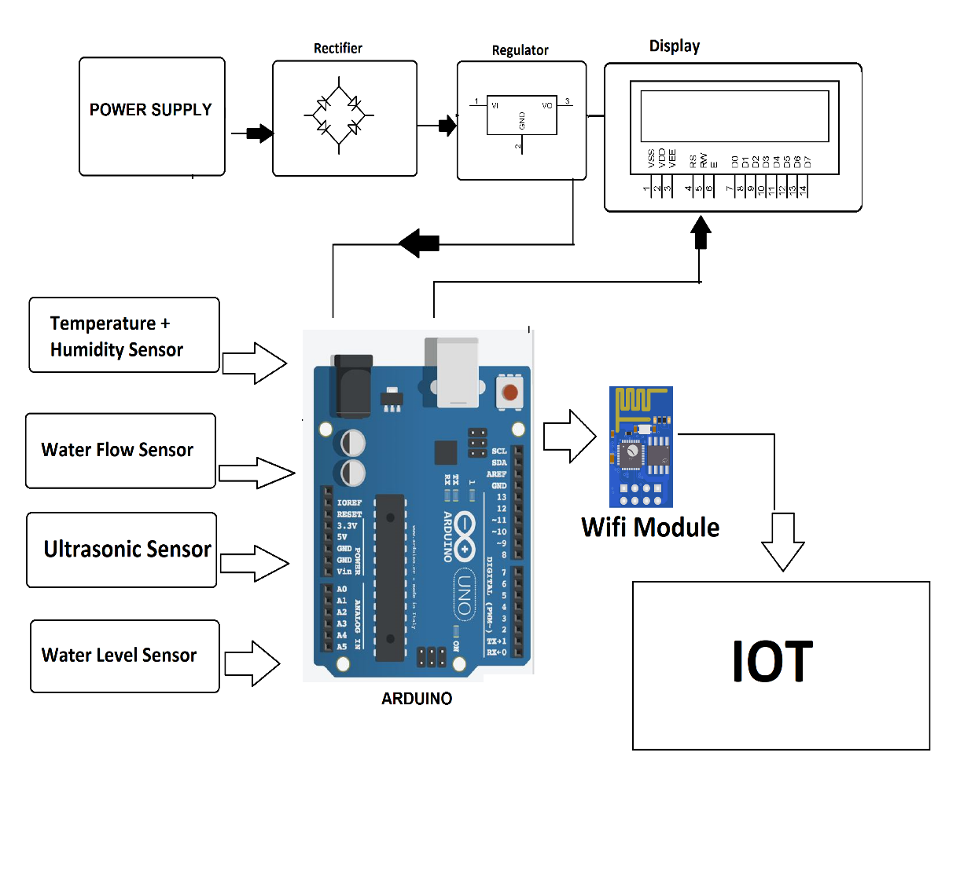

Software implementation

For software part we have integrated our system with android we developed an android system that is fully capable of monitoring the system environment. This is done using the data sent by the system. Using an android app makes it for mobile and convenient to use as the app is just one click away. Every detail related to thesystem can be viewed in this app. It can notify the user if there is anypossibility of flood to occur. For e.g. certain rise in water flow increasing the overall water level of the dam/container (in our case) the application is versatile enough to let the user know about this and report it before hand in order to avoid any form of casualties. The application can also to be used to monitor sensor data in real time that is it can provide:

i) Distance from ultrasonic sensor to water.

ii) The flow rate of water.

iii) Total volume of water and

iv) Temperature and humidity.

All these features provided by the application can be efficiently used by any individual to monitor the system. It is user friendly and avoids complication of different data used as the user is only provided

with what really is important.

Conclusion

Disasters, as the name suggests, brings about great havoc on lives and property indiscriminately across the globe. Developing countries, however, experience much worse destruction than the developed ones and are as well as less equipped to

deal with the aftereffects of these calamities. Foreknowledge of the disaster could thus help all, especially the developing countries by providing time to secure property and evacuate. Developing early warning systems may be complicated, with many facets to the system requirements and many additional intricacies, when within a developing country.